 

**6CS007**

**PROJECT AND PROFESSIONALISM**

**ARTEFACT DESIGN AND TEST PLAN**

**NYAYAMITRA: RAG based AI for Nepali legal Q&A**

University Id

Group

Reader

Supervisor

Student Name

Course

Submitted on

: 2408239

: L6CG15

: Mr. Akash Adhikari

: Mr. Yamu Poudel

: Nikisha Shrestha

: BSc (Hons) Computer Science

: 12/26/2025

**Table of Contents**

List of Table ii

List of Figures iii

Artefact Design 1

FDD - Functional Decomposition Diagram 1

Subsystems 1

1. User Management Module 1

1.1. SRS Document 1

1.2. Use Case Diagram 3

1.3. Activity Diagram 4

1.4. ERD 4

1.5. Wireframe 5

2. Document Management Module 9

2.1. SRS Document 9

2.2. Use Case Diagram 11

2.3. Activity Diagram 12

2.4. ERD 12

2.5. Data Dictionary 13

3. Personalization/Onboarding Module 13

3.1. SRS Document 13

3.2. Use Case Diagram 16

3.3. Activity Diagram 17

3.4. ERD 18

3.5. Wireframe 19

4. Retrieval & Enbeddings Module 26

4.1. SRS Document 26

4.2. Use Case Diagram 29

4.3. Activity Diagram 30

5. Language & Model Handling Module 31

5.1. SRS Document 31

5.2. Use Case Diagram 33

5.3. Activity Diagram 33

6. Legal NLP Processing Module 35

6.1. SRS Document 35

6.2. Use Case Diagram 37

6.3. Activity Diagram 38

7. Frontend & User Interface Module 40

7.1. SRS Document 40

7.2. Use Case Diagram 42

7.3. Activity Diagram 42

8. Security & Deployment Module 44

8.1. SRS Document 44

8.2. Use Case Diagram 46

8.3. Activity Diagram 47

Test Plan 48

1. User Management Module 48

2. Document Management Module 48

3. Personalization Module 49

4. Retrieval & Embedding Module 49

5. Language & Model Handling Module 50

6. Legal NLP Processing Module 50

7. Frontend & User Interface Module 51

8. Security & Deployment Module 52

# List of Table

Table 1: UM-FunctionalRequirement 1

Table 2: UM-Non-FuunctionalRequirement 2

Table 3: UM-UsabilityRequirement 2

Table 4: DM-FunctionalRequirement 9

Table 5: DM-Non-FunctionalRequirement 10

Table 6: DM-UsabilityRequirement 10

Table 7: PM--FunctionalRequirement 13

Table 8: PM--Non-FunctionalRequirement 14

Table 9: PM--UsabilityRequirement 15

Table 10: RE--FunctionalRequirement 26

Table 11: RE--Non-FunctionalRequirement 27

Table 12: RE--UsabilityRequirement 28

Table 13: LM--FunctionalRequirement 31

Table 14: LM--Non-FunctionalRequirement 31

Table 15: LM--UsabilityRequirement 32

Table 16: NLP--FunctionalRequirement 35

Table 17: NLP--Non-FunctionalRequirement 35

Table 18: NLP--UsabilityRequirement 36

Table 19: FUI--FunctionalRequirement 40

Table 20: FUI--Non-FunctionalRequirement 40

Table 21: FUI--UsabilityRequirement 41

Table 22: SD--FunctionalRequirement 44

Table 23: SD--Non-FunctionalRequirement 44

Table 24: SD--UsabilityRequirement 45

# List of Figures

Figure 1: FDD-Functional Decomposition Diagram 1

Figure 2: UM-UseCaseDiagram 3

Figure 3: UM-ActivityDiagram 4

Figure 4: UM-ERD 4

Figure 5: UM-LandingPageWireframe 5

Figure 6: UM-RegisterWireframe 6

Figure 7: UM-LoginWireframe 7

Figure 8: UM-EditProfileWireframe 8

Figure 9: UM-LogoutWireframe 9

Figure 10: DM-UseCaseDiagram 11

Figure 11: DM-Activitydiiagram 12

Figure 12:DM-ERD 13

Figure 13: DM-DataDictionary 13

Figure 14: PM-UseCaseDiagram 16

Figure 15: PM-ActivityDiagram 17

Figure 16: PM-ERD 18

Figure 17: PM-EditNameWireframe 19

Figure 18: PM-AreYouALawyerWireframe 20

Figure 19: PM-NBA&LicenseYearWireframe 21

Figure 20: PM-PracticeAreaWireframe 22

Figure 21: PM-CourtJurisdictionWireframe 23

Figure 22: PM-SelectProvinceWireframe 24

Figure 23: PM-PersonalizationCompleteWireframe 25

Figure 24: PM-SkippedPersonalizationWireframe 26

Figure 25: RE-UseCaseDiagram 29

Figure 26: RE-ActivityDiagram 30

Figure 27: LM-UseCaseDiagram 33

Figure 28: LM-ActivityDiagram 34

Figure 29: NLP-UseCaseDiagram 37

Figure 30: NLP-ActivityDiagram 40

Figure 31: FUI-UseCaseDiagram 42

Figure 32: FUI-ActivityDiagram 43

Figure 33: SD-UseCaseDiagram 46

Figure 34: SD-ActivityDiagram 47

Figure 35: UM-TestPlan 48

Figure 36: DM-TestPlan 49

Figure 37: PM-TestPlan 49

Figure 38: RE-TestPlan 50

Figure 39: LM-TestPlan 50

Figure 40: NLP-TestPlan 51

Figure 41: TestPlan 51

Figure 42: SD-TestPlan 52

# Artefact Design

## FDD - Functional Decomposition Diagram

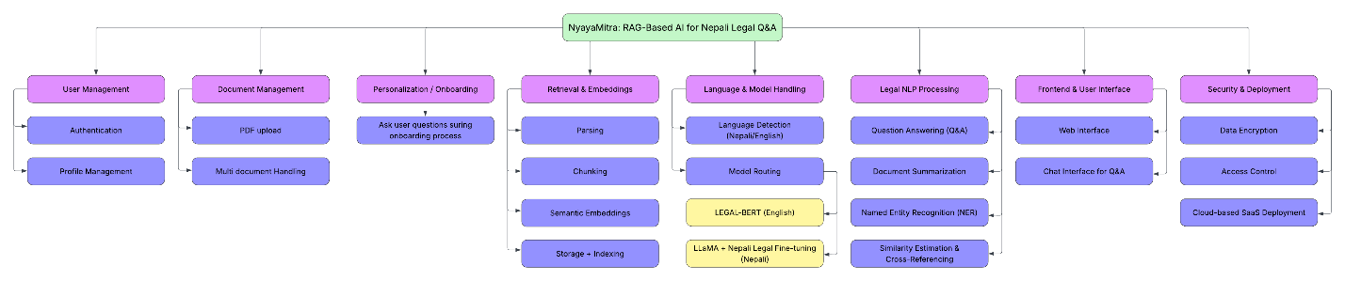

Figure 1: FDD-Functional Decomposition Diagram

## Subsystems

### User Management Module

#### SRS Document

Functional Requirement

Table 1: UM-FunctionalRequirement

|  |  |
| --- | --- |
| Requirement Code | Requirement Description |
| UM-F-1.0 | The system must allow the user to register using email and password. |
| UM-F-1.1 | The system will validate email format before submission. |
| UM-F-1.2 | The system must validate password strength (letters, numbers, special characters). |
| UM-F-1.3 | The system must allow the user to log in. |
| UM-F-1.4 | The system must allow users to view and edit their own profile (name, profile picture). |
| UM-F-1.5 | The system must allow users to log out from the web interface. |

Non-Functional Requirement

Table 2: UM_Non-FuunctionalRequirement

|  |  |
| --- | --- |
| Requirement Code | Requirement Description |
| UM-NF-1.0 | All data submitted via the browser must be encrypted using HTTPS/TLS. |
| UM-NF-1.1 | Passwords must be stored using a secure hashing algorithm (bcrypt/argon2). |
| UM-NF-1.2 | The login and registration pages must load within 2-3 seconds on standard broadband. |
| UM-NF-1.3 | The session must use secure cookies (HttpOnly, SameSite, Secure flags). |

Usability Requirement

Table 3: UM-UsabilityRequirement

|  |  |
| --- | --- |
| Requirement Code | Requirement Description |
| UM-UR-1.0 | The password field must include a show/hide toggle icon. |
| UM-UR-1.1 | Error messages must be clear and displayed directly on the form (e.g., under the input field). |
| UM-UR-1.2 | Forms must provide inline validation (email checking, password strength indicator). |
| UM-UR-1.3 | The profile update page must be easy to navigate and must preview uploaded profile pictures. |
| UM-UR-1.4 | Buttons and forms should follow consistent styling throughout the web interface. |

#### Use Case Diagram

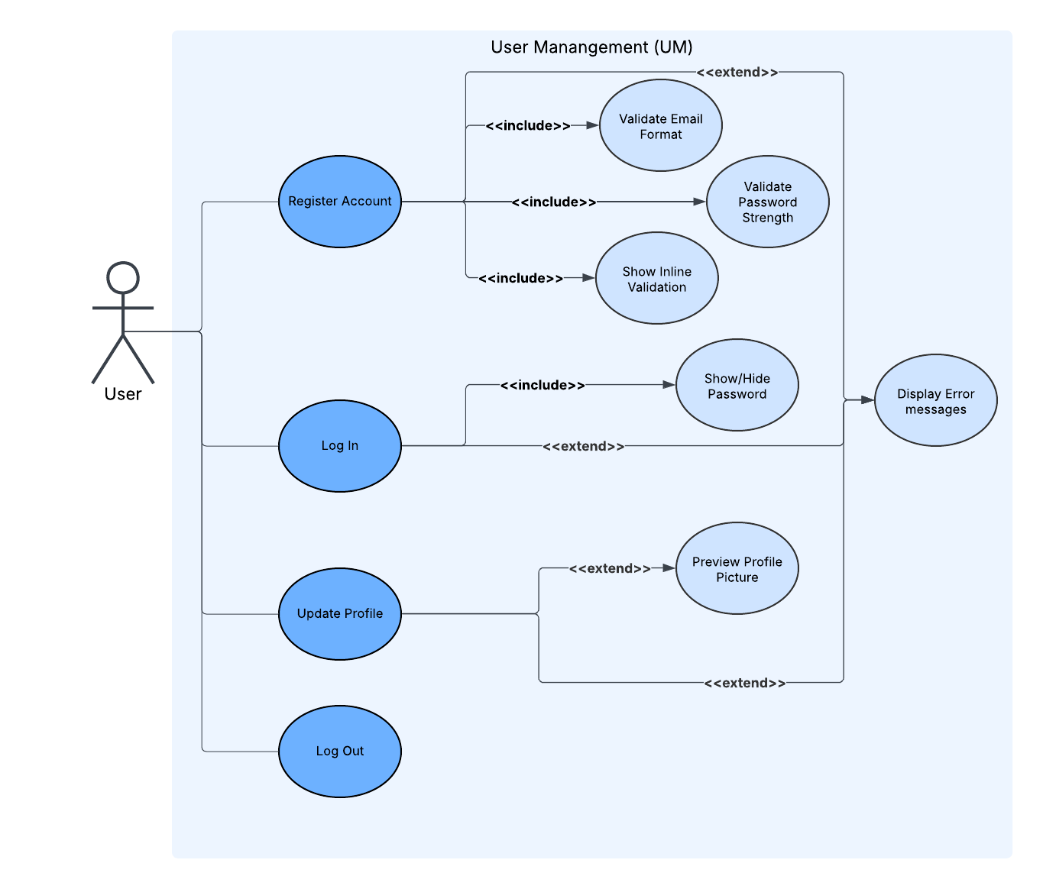

Figure 2: UM-UseCaseDiagram

#### Activity Diagram

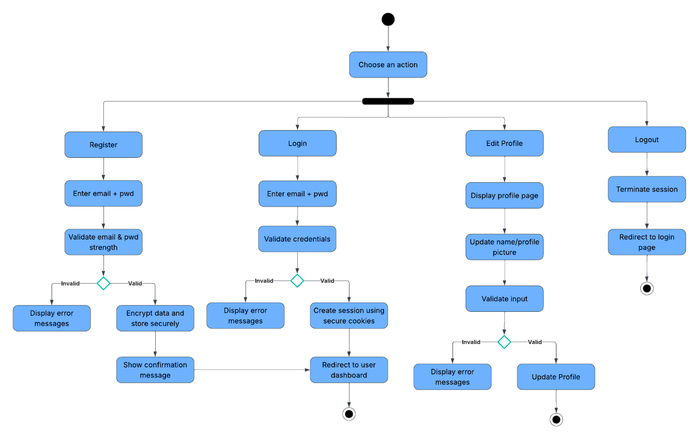

Figure 3: UM-ActivityDiagram

#### ERD

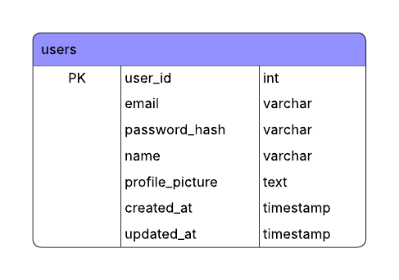

Figure 4: UM-ERD

#### Wireframe

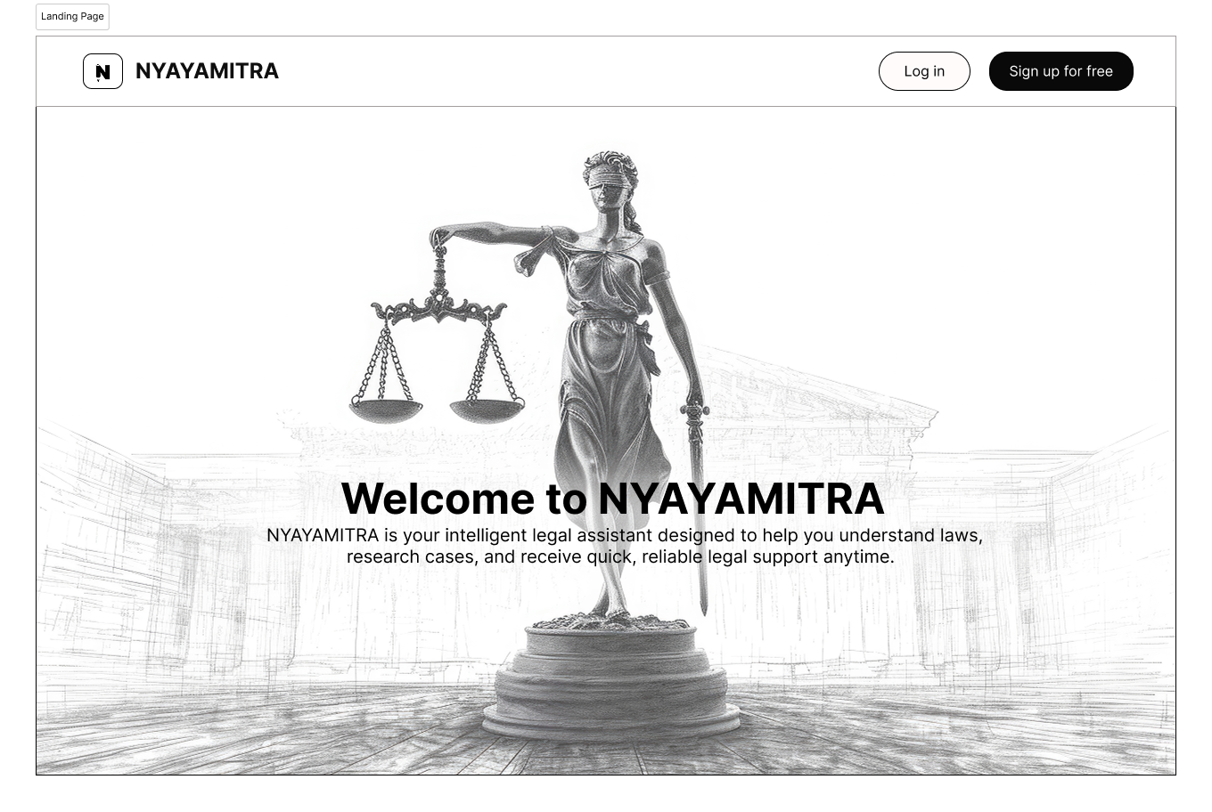

Figure 5: UM-LandingPageWireframe

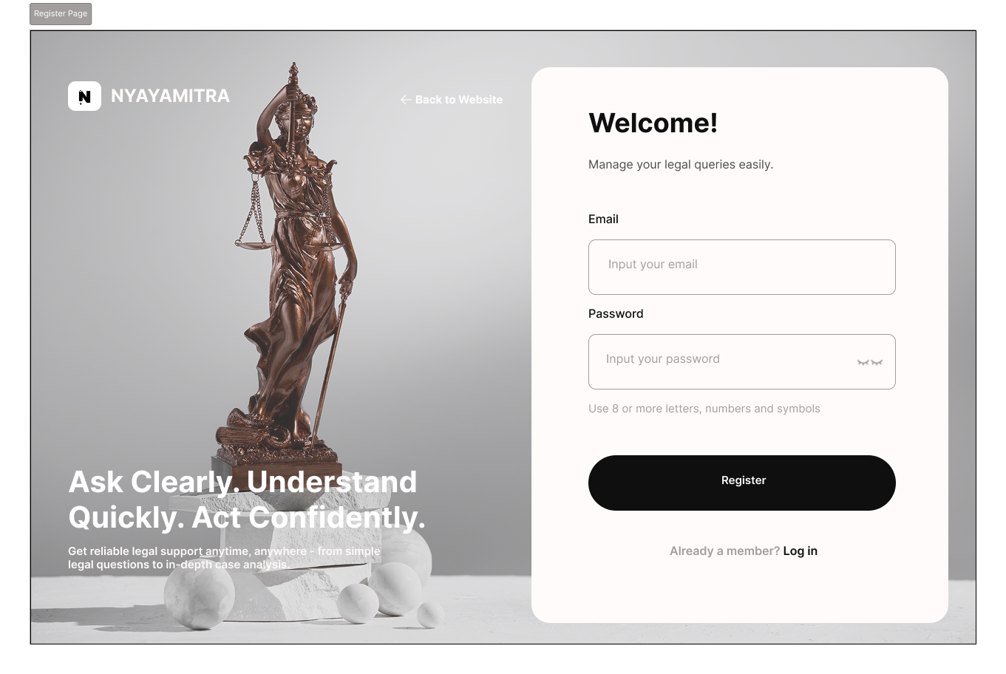

Figure 6: UM-RegisterWireframe

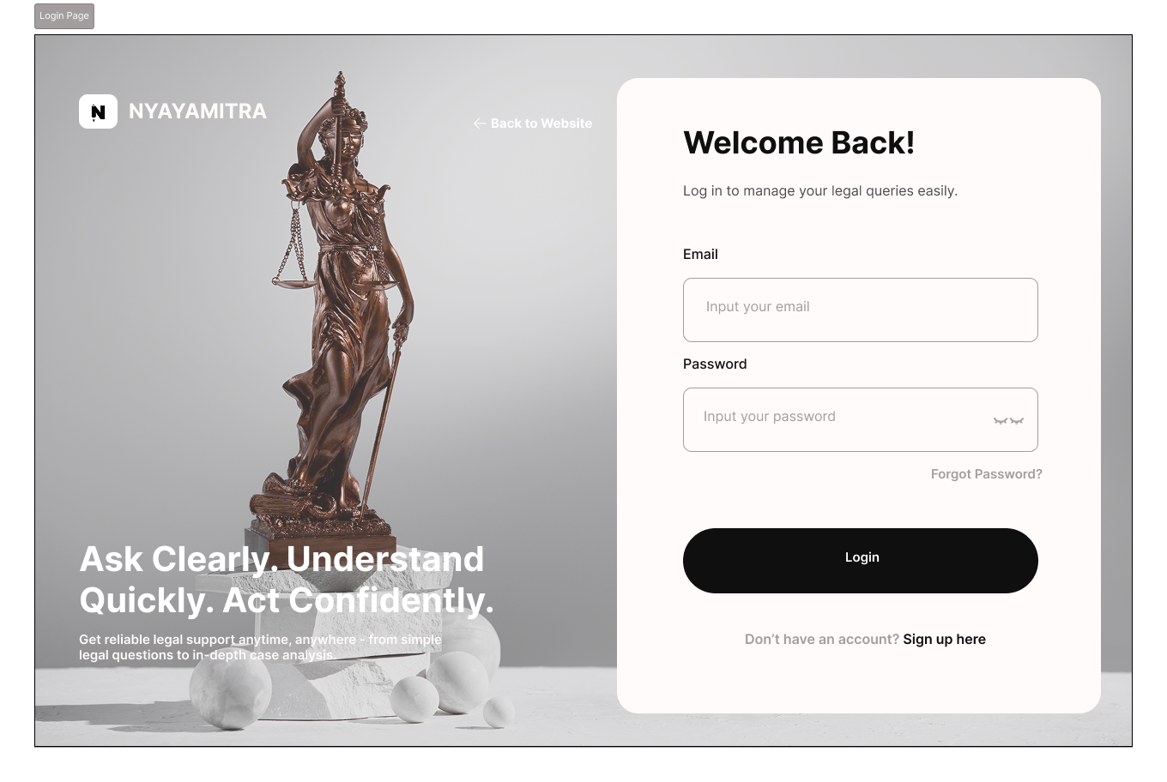

Figure 7: UM-LoginWireframe

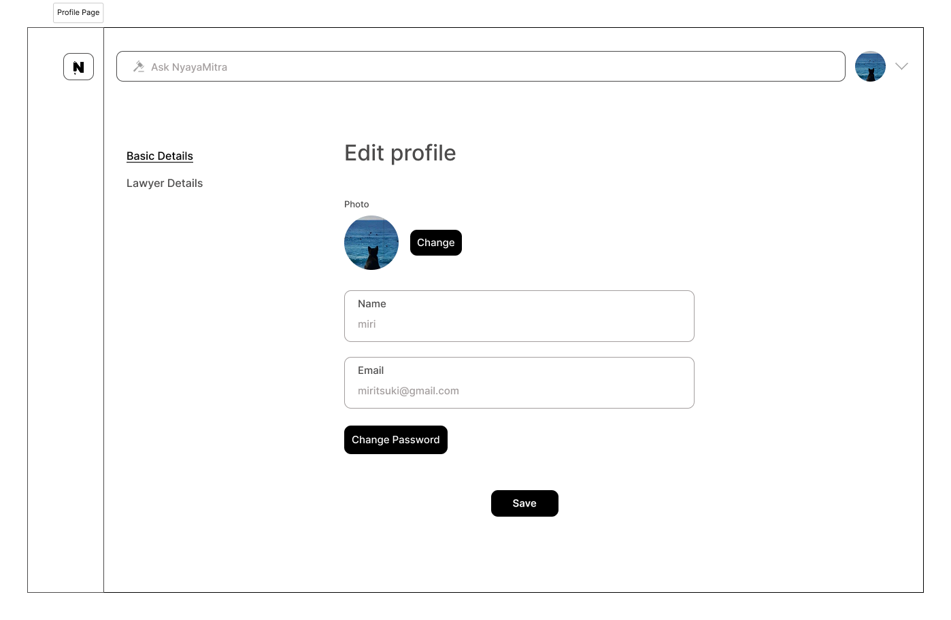

Figure 8: UM-EditProfileWireframe

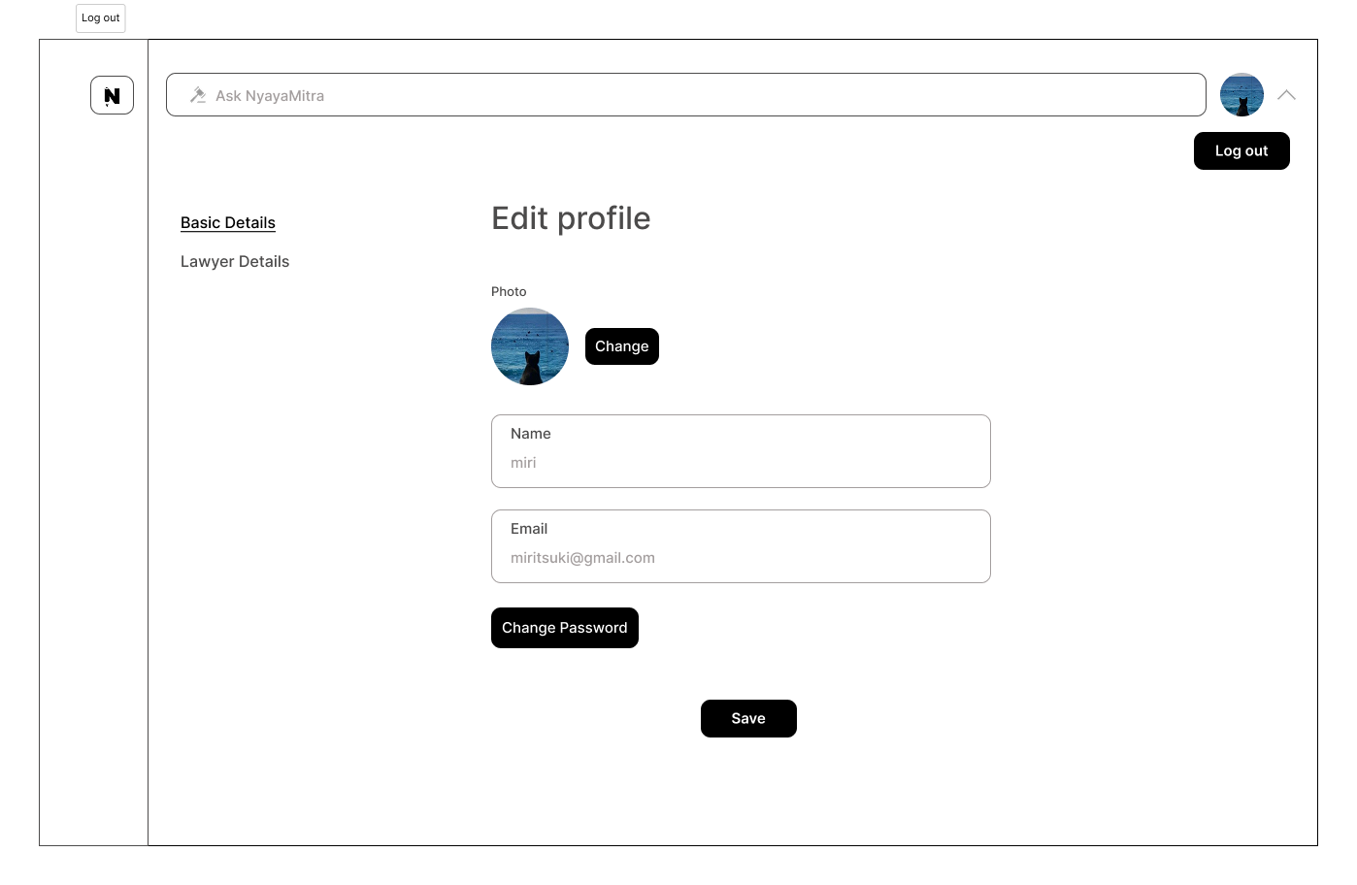

Figure 9: UM-LogoutWireframe

### Document Management Module

#### SRS Document

Functional Requirement

Table 4: DM-FunctionalRequirement

|  |  |
| --- | --- |
| Requirement Code | Requirement Description |
| DM-F-1.0 | The system must allow users to upload PDF documents. |
| DM-F-1.1 | Users can upload multiple PDFs simultaneously. |
| DM-F-1.2 | The system must allow users to preview a list of uploaded documents. |
| DM-F-1.3 | Users can perform batch queries across multiple documents. |
| DM-F-1.4 | The system must allow cross-document comparisons (e.g., searching for the same term in multiple PDFs). |
| DM-F-1.5 | Users can delete uploaded documents. |

Non-Functional Requirement

Table 5: DM-Non-FunctionalRequirement

|  |  |
| --- | --- |
| Requirement Code | Requirement Description |
| DM-NF-1.0 | All PDF uploads and downloads must be transmitted over HTTPS/TLS. |
| DM-NF-1.1 | Uploaded PDFs must be stored securely with access control to prevent unauthorized access. |
| DM-NF-1.2 | The system must handle simultaneous uploads of at least 20 PDFs without performance degradation. |
| DM-NF-1.3 | |  | | --- | | Document processing (search, comparison) must complete within 5 seconds for up to 10 documents of 10 MB each. | |

Usability Requirement

Table 6: DM-UsabilityRequirement

|  |  |
| --- | --- |
| Requirement Code | Requirement Description |
| DM-UR-1.0 | |  | | --- | | The upload interface must allow drag-and-drop for multiple PDFs. | |
| DM-UR-1.1 | |  | | --- | | Progress bars should show upload status for each PDF. | |
| DM-UR-1.2 | |  | | --- | | Error messages must be clear and displayed near the document upload area (e.g., file too large, invalid format). | |

#### Use Case Diagram

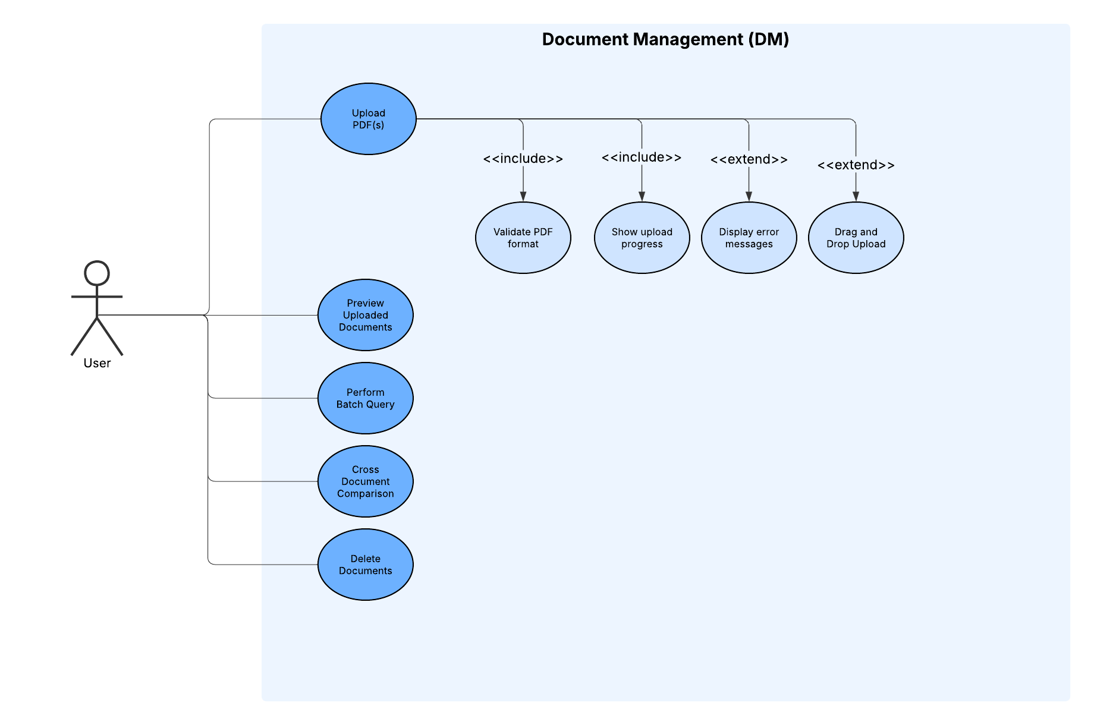

Figure 10: DM-UseCaseDiagram

#### Activity Diagram

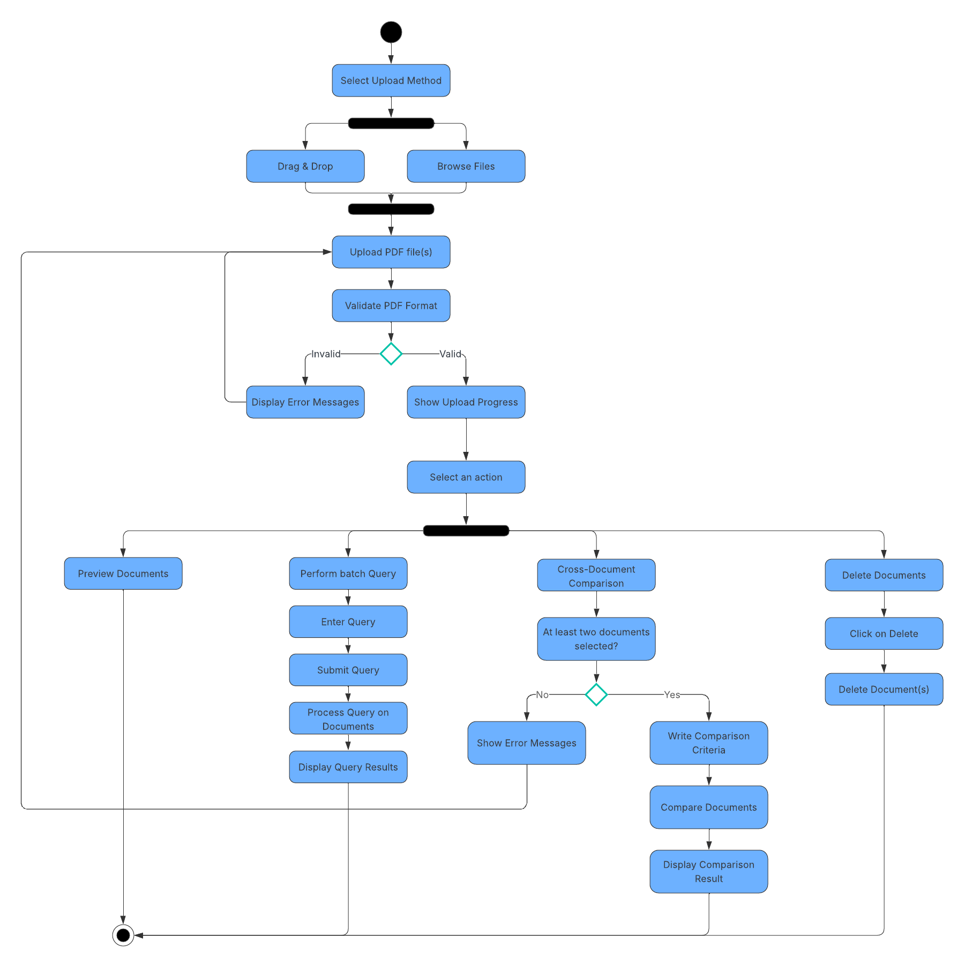

Figure 11: DM-Activitydiiagram

#### ERD

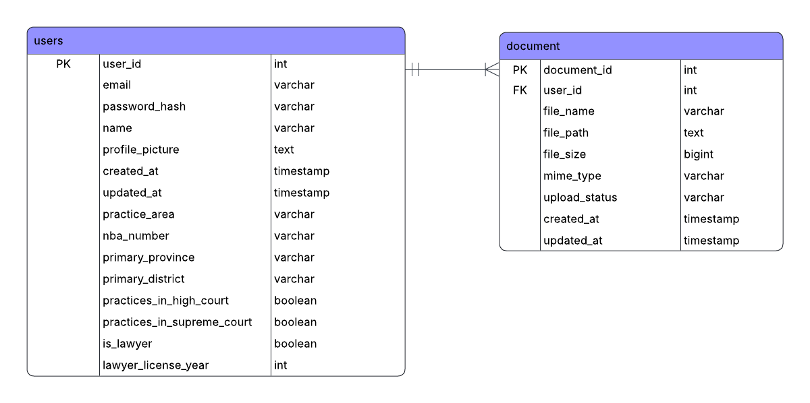

Figure 12:DM-ERD

#### Data Dictionary

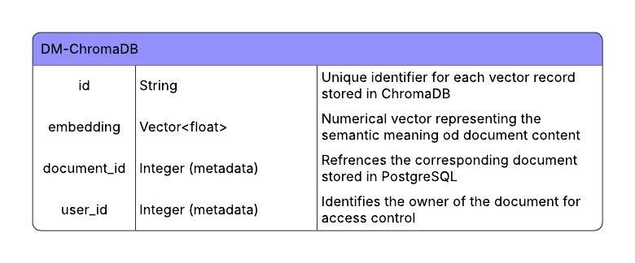

Figure 13: DM-DataDictionary

### Personalization/Onboarding Module

#### SRS Document

Functional Requirement

Table 7: PM--FunctionalRequirement

|  |  |
| --- | --- |
| Requirement Code | Requirement Description |
| PM-F-1.0 | |  | | --- | |  |  |  | | --- | | The system must display a personalization onboarding flow immediately after successful user signup. | |
| PM-F-1.1 | Users can edit their name during onboarding process. |
| PM-F-1.2 | The system must ask the user whether they are a lawyer using a Yes/No pop-up question. |
| PM-F-1.3 | If the user selects “Yes (Lawyer)”, the system must display additional pop-up questions for lawyer-specific details. |
| PM-F-1.4 | For lawyer users, the system must collect the Nepal Bar Association (NBA) number. |
| PM-F-1.5 | |  | | --- | |  |  |  | | --- | | For lawyer users, the system must collect the user’s legal practice area. | |
| PM-F-1.6 | For lawyer users, the system must collect the court jurisdiction in which the user practices. |
| PM-F-1.7 | |  | | --- | |  |  |  | | --- | | If the user selects “No (Non-Lawyer)”, the system must skip lawyer-specific questions. | |
| PM-F-1.8 | The system must mark personalization as completed after successful submission of onboarding details. |
| PM-F-1.9 | Users have the option to skip personalization steps. |
| PM-F-1.10 | The system must redirect the user to the dashboard after onboarding is completed. |
| PM-F-1.11 | |  | | --- | |  |  |  | | --- | | The system must allow users to update their personal and professional details later through profile management. | |

Non-Functional Requirement

Table 8: PM--Non-FunctionalRequirement

|  |  |
| --- | --- |
| Requirement Code | Requirement Description |
| PM-NF-1.0 | The onboarding pop-up flow must be responsive and load within acceptable time limits. |
| PM-NF-1.1 | Personal and professional data collected during onboarding must be securely stored. |
| PM-NF-1.2 | |  | | --- | |  |  |  | | --- | | The subsystem must ensure data consistency between onboarding inputs and stored user profile information. | |
| PM-NF-1.3 | |  | | --- | |  |  |  | | --- | | The system must support concurrent onboarding sessions for multiple users without performance degradation. | |
| PM-NF-1.4 | Sensitive professional information (e.g., NBA number) must not be exposed to unauthorized users or components. |

Usability Requirement

Table 9: PM--UsabilityRequirement

|  |  |
| --- | --- |
| Requirement Code | Requirement Description |
| PM-UR-1.0 | The onboarding process must be presented using clear, sequential pop-up questions. |
| PM-UR-1.1 | |  | | --- | |  |  |  | | --- | | Validation errors must be clearly displayed within the pop-up interface. | |
| PM-UR-1.2 | |  | | --- | |  |  |  | | --- | | The onboarding interface must be easy to understand and require minimal user effort. | |
| PM-UR-1.3 | |  | | --- | |  |  |  | | --- | | Users must receive clear confirmation when personalization is successfully completed. | |

#### Use Case Diagram

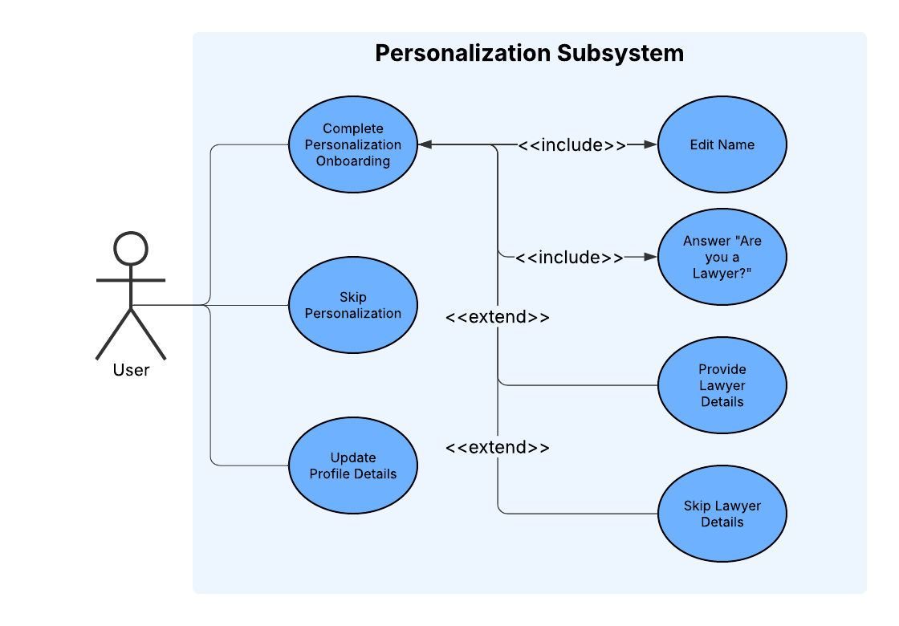

Figure 14: PM-UseCaseDiagram

#### Activity Diagram

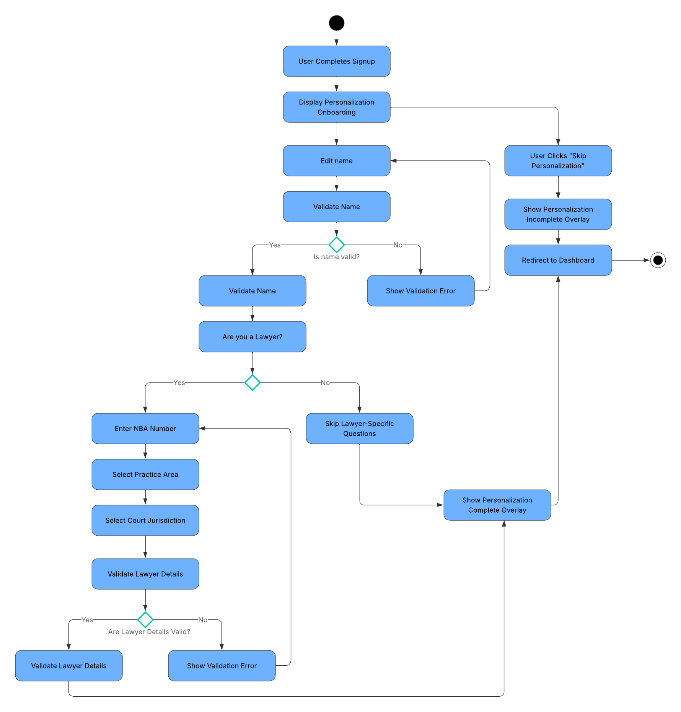

Figure 15: PM-ActivityDiagram

#### ERD

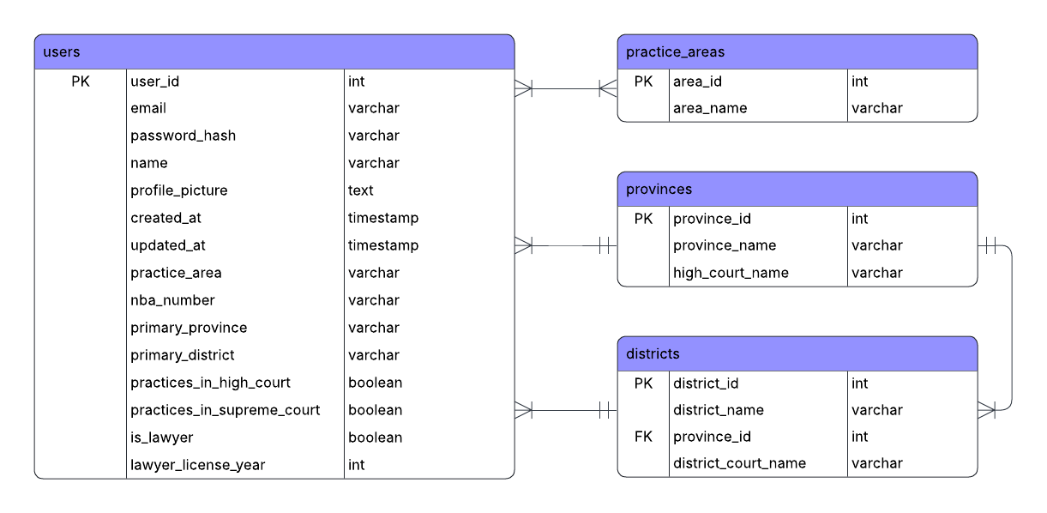

Figure 16: PM-ERD

#### Wireframe

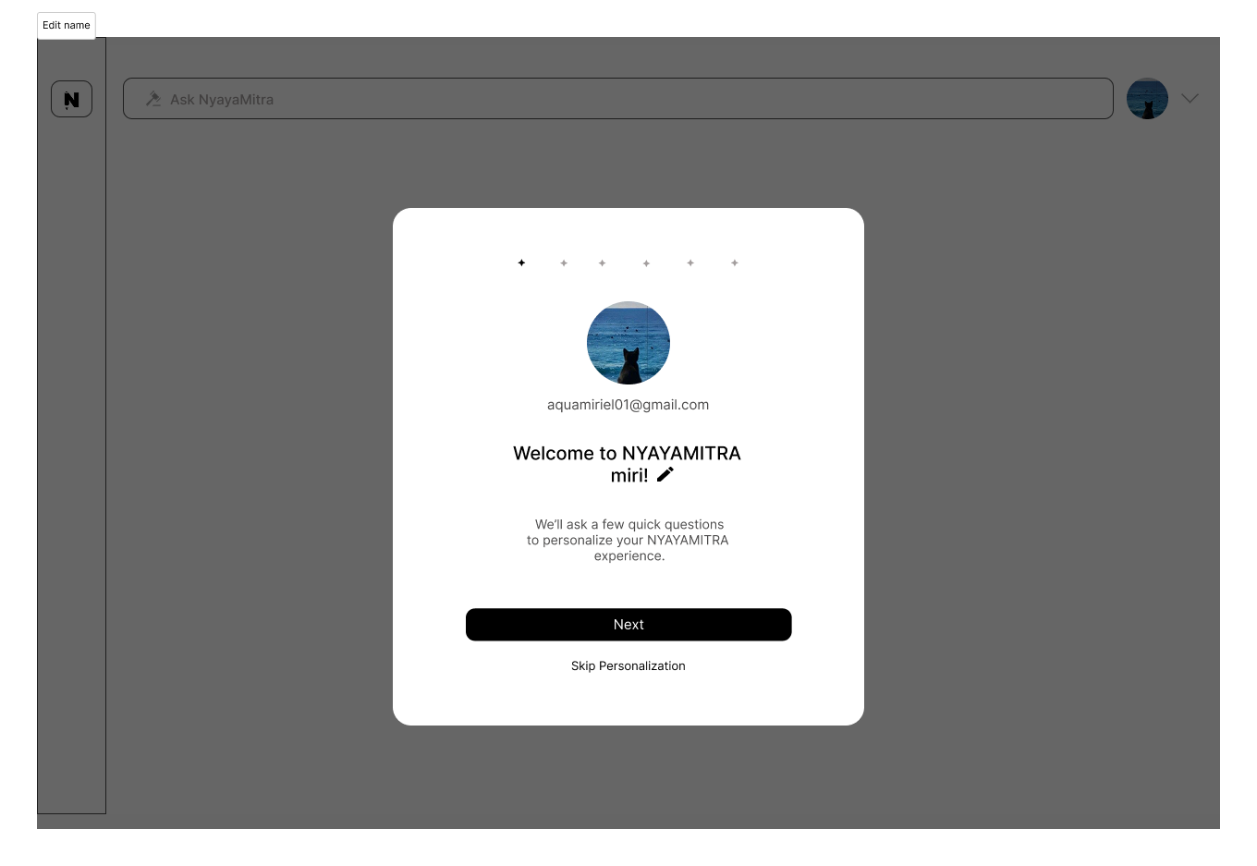

Figure 17: PM-EditNameWireframe

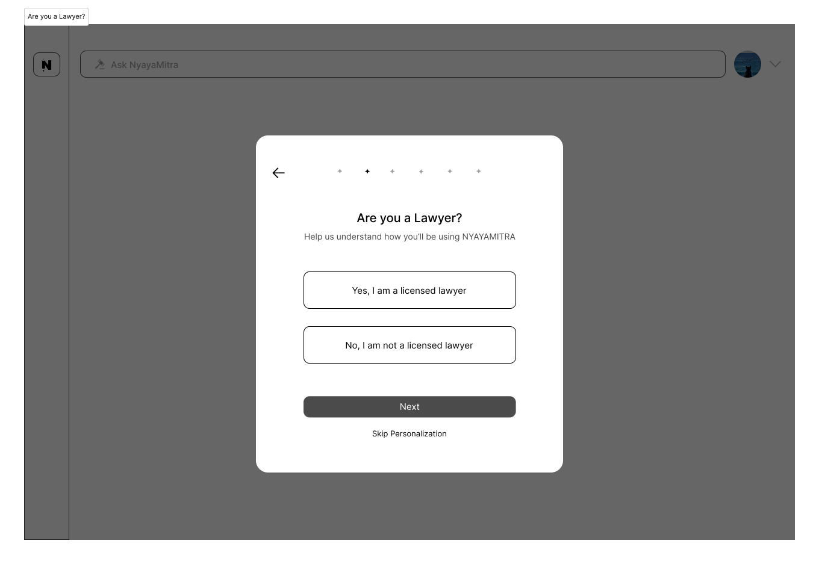

Figure 18: PM-AreYouALawyerWireframe

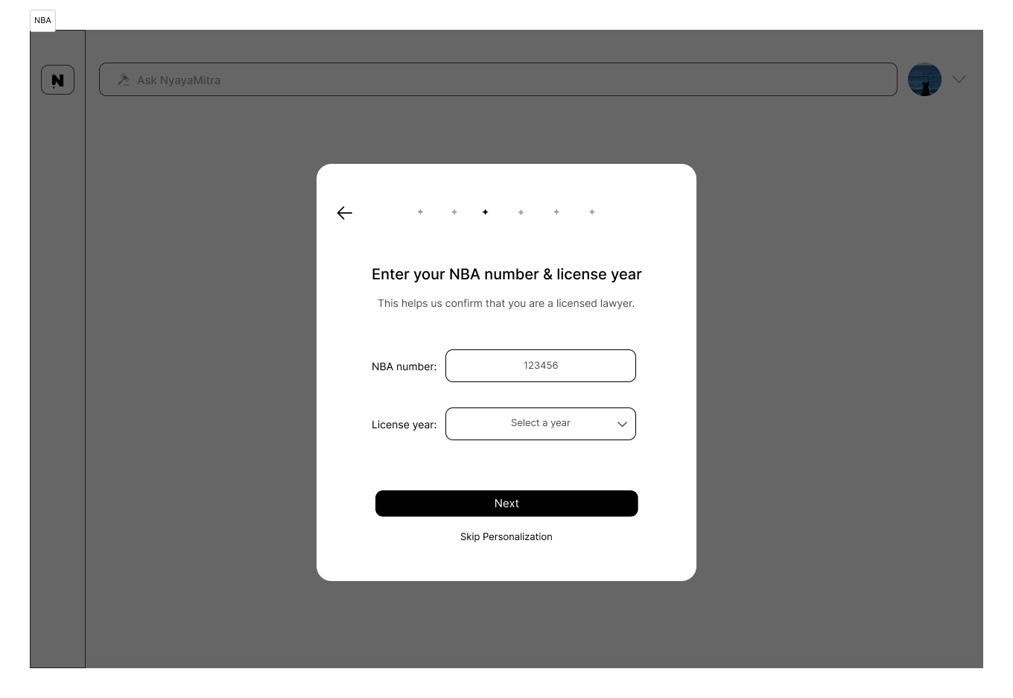

Figure 19: PM-NBA&LicenseYearWireframe

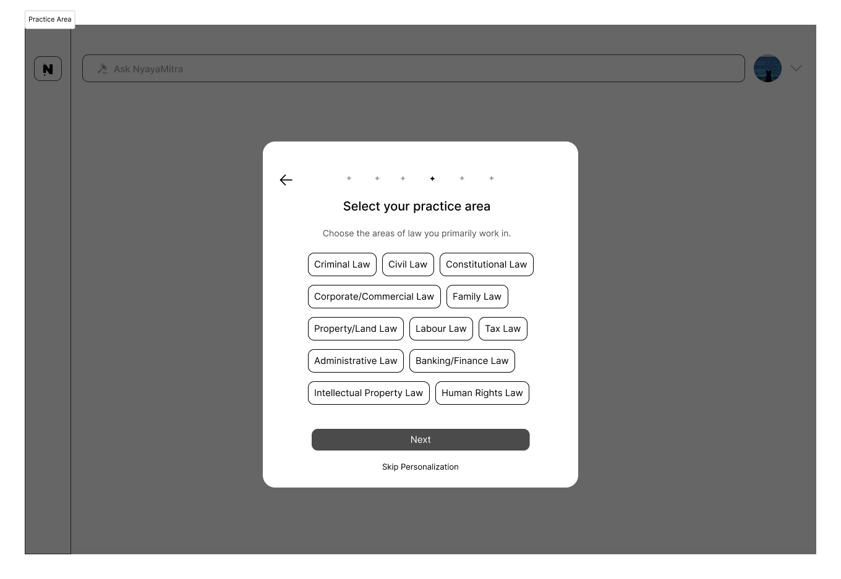

Figure 20: PM-PracticeAreaWireframe

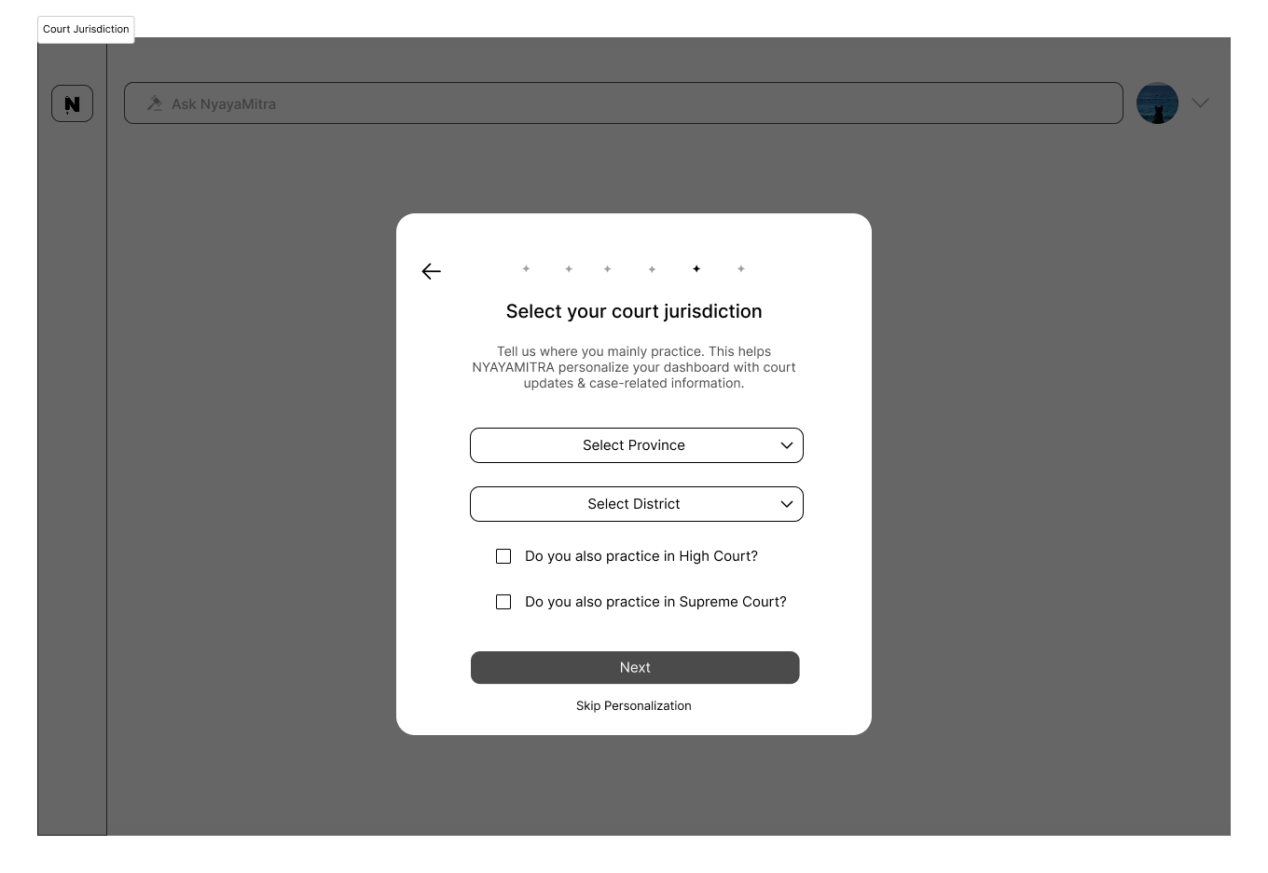

Figure 21: PM-CourtJurisdictionWireframe

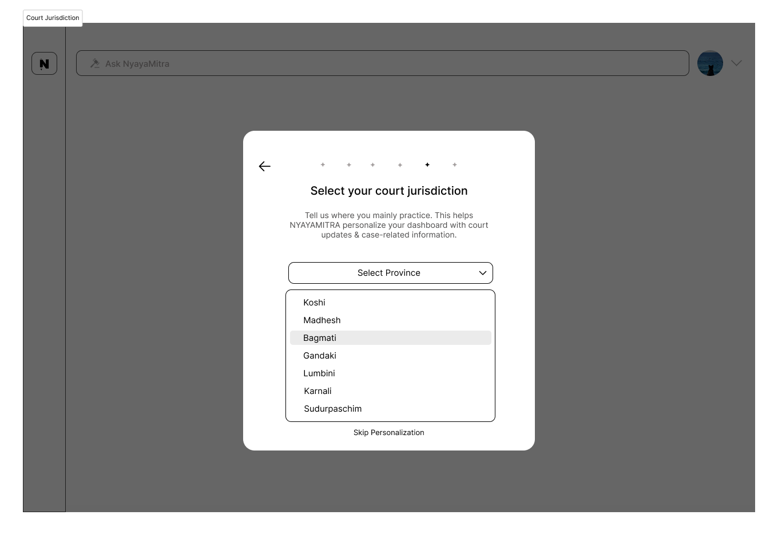

Figure 22: PM-SelectProvinceWireframe

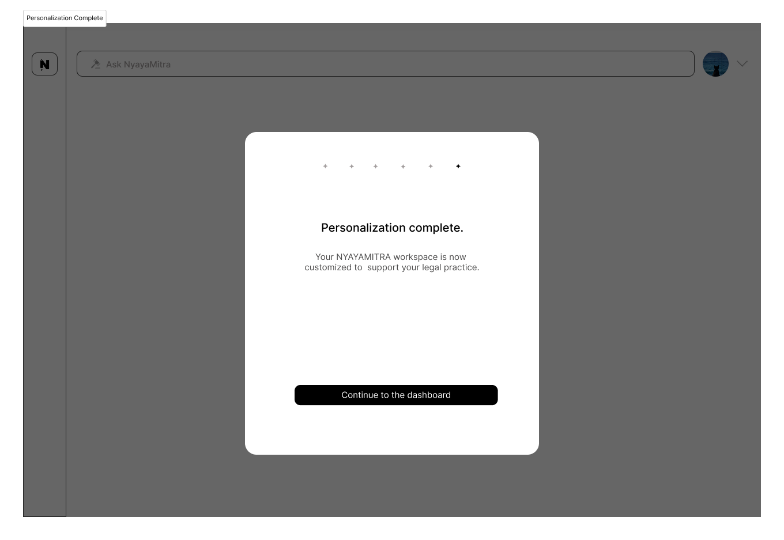

Figure 23: PM-PersonalizationCompleteWireframe

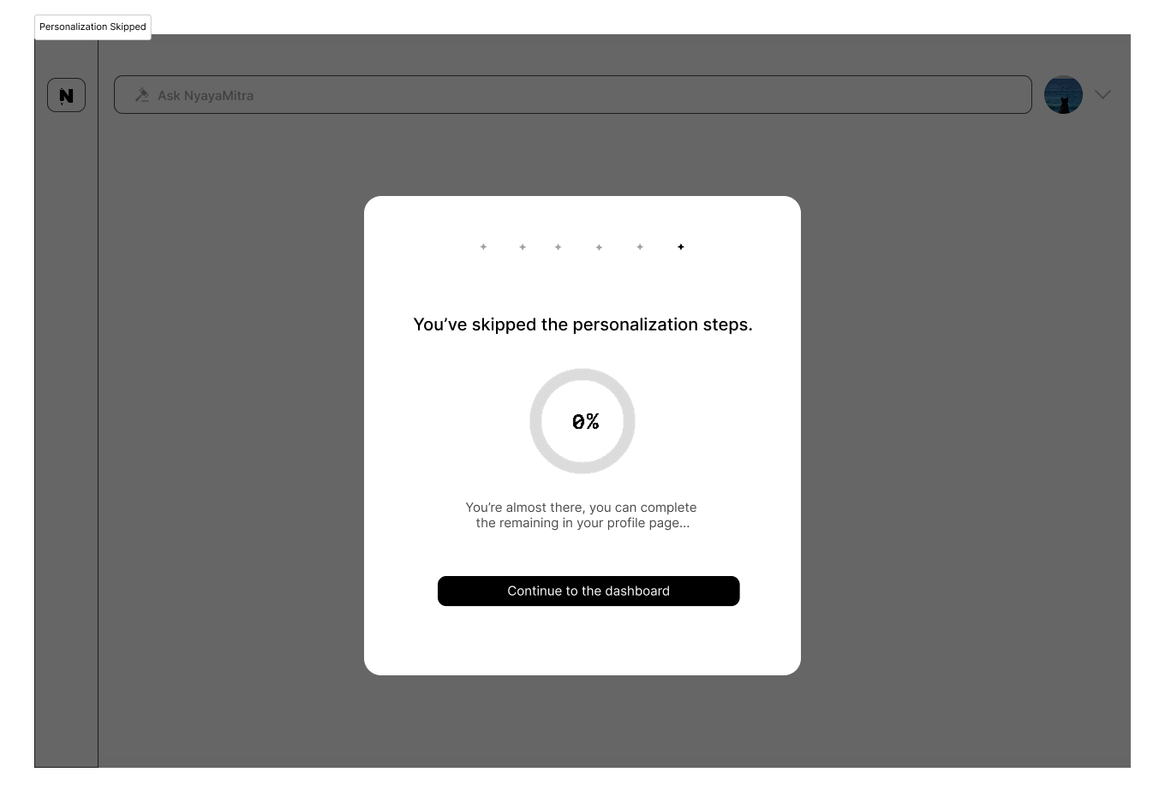

Figure 24: PM-SkippedPersonalizationWireframe

### Retrieval & Enbeddings Module

#### SRS Document

Functional Requirement

Table 10: RE--FunctionalRequirement

|  |  |
| --- | --- |
| Requirement Code | Requirement Description |
| RE-F-1.0 | The system must automatically parse uploaded PDF documents to extract textual content. |
| RE-F-1.1 | The system must support parsing of multi-page PDF documents. |
| RE-F-1.2 | The system must divide parsed document content into structured chunks (e.g., sections, articles, paragraphs). |
| RE-F-1.3 | The system must generate semantic embeddings for each document chunk. |
| RE-F-1.4 | The system must store generated embeddings in a vector database for retrieval. |
| RE-F-1.5 | The system must associate each embedding with its corresponding document identifier. |
| RE-F-1.6 | |  | | --- | |  |  |  | | --- | | The system must support semantic similarity search across stored embeddings. | |
| RE-F-1.7 | |  | | --- | |  |  |  | | --- | | The system must retrieve relevant document chunks based on user queries. | |
| RE-F-1.8 | The system must support batch retrieval across multiple documents. |

Non-Functional Requirement

Table 11: RE--Non-FunctionalRequirement

|  |  |
| --- | --- |
| Requirement Code | Requirement Description |
| RE-NF-1.0 | |  | | --- | |  |  |  | | --- | | Document parsing, chunking, and embedding generation must be executed in a secure server environment. | |
| RE-NF-1.1 | |  | | --- | |  |  |  | | --- | | The system must ensure that embeddings are only retrievable by authorized users. | |
| RE-NF-1.2 | Embedding generation must complete within acceptable time limits for documents up to 10 MB in size. |
| RE-NF-1.3 | The vector retrieval process must return relevant results within 5 seconds for standard queries. |
| RE-NF-1.4 | |  | | --- | |  |  |  | | --- | | The system must be scalable to handle concurrent embedding generation for multiple documents. | |
| RE-NF-1.5 | |  | | --- | |  |  |  | | --- | | The system must log embedding and retrieval operations for monitoring and debugging purposes. | |

Usability Requirement

Table 12: RE--UsabilityRequirement

|  |  |
| --- | --- |
| Requirement Code | Requirement Description |
| RE-UR-1.0 | The system must process documents in the background without requiring manual user intervention. |
| RE-UR-1.1 | |  | | --- | |  |  |  | | --- | | Users must receive clear status indicators when documents are ready for semantic search. | |
| RE-UR-1.2 | |  | | --- | |  |  |  | | --- | | Error messages related to parsing or embedding failures must be descriptive and user-friendly. | |
| RE-UR-1.3 | Retrieved document chunks must be presented in a readable and understandable format. |
| RE-UR-1.4 | |  | | --- | |  |  |  | | --- | | The system should highlight relevant portions of retrieved content when displaying results. | |

#### Use Case Diagram

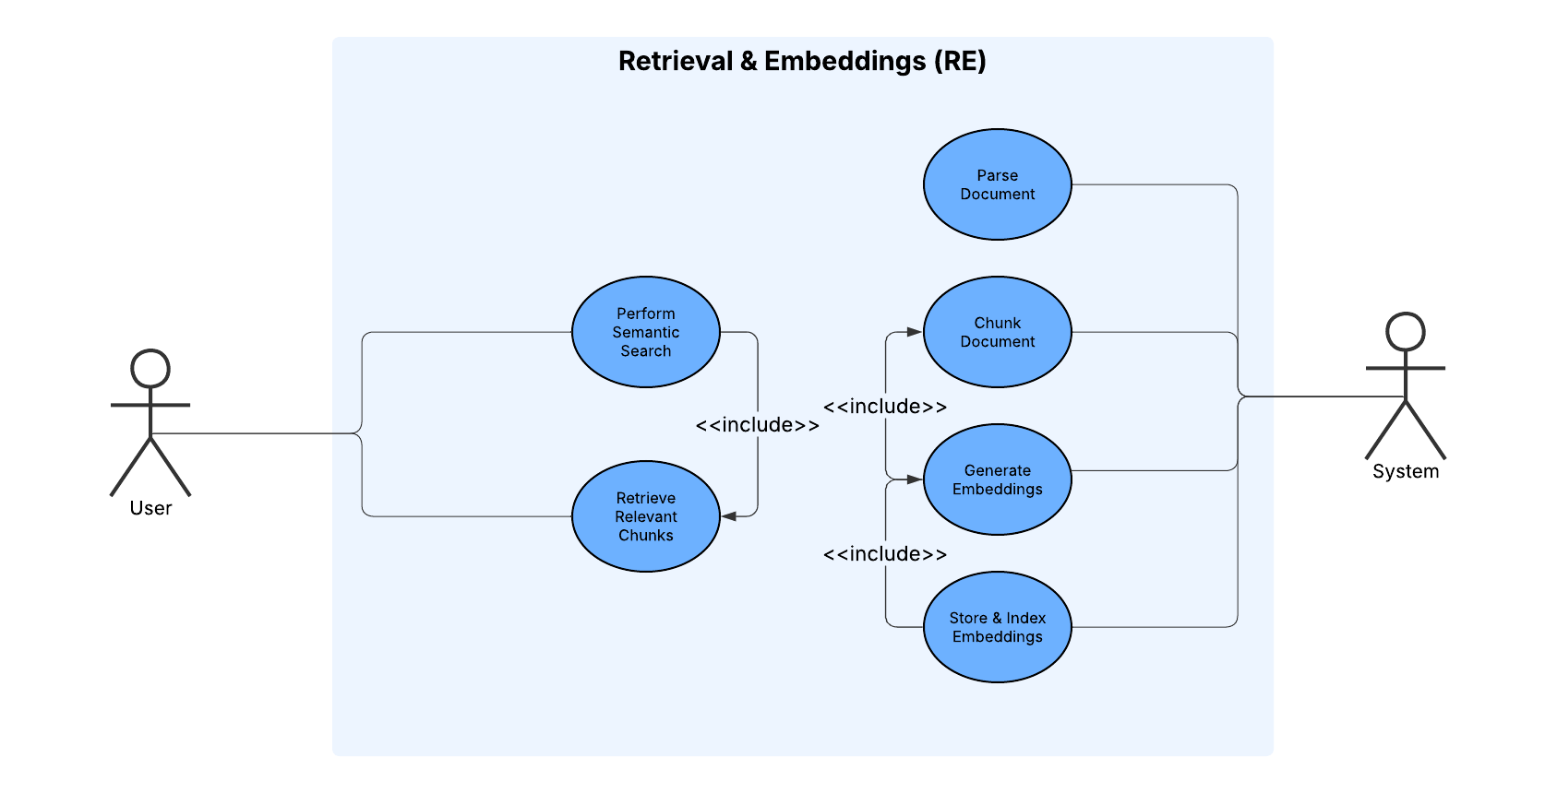

Figure 25: RE-UseCaseDiagram

#### Activity Diagram

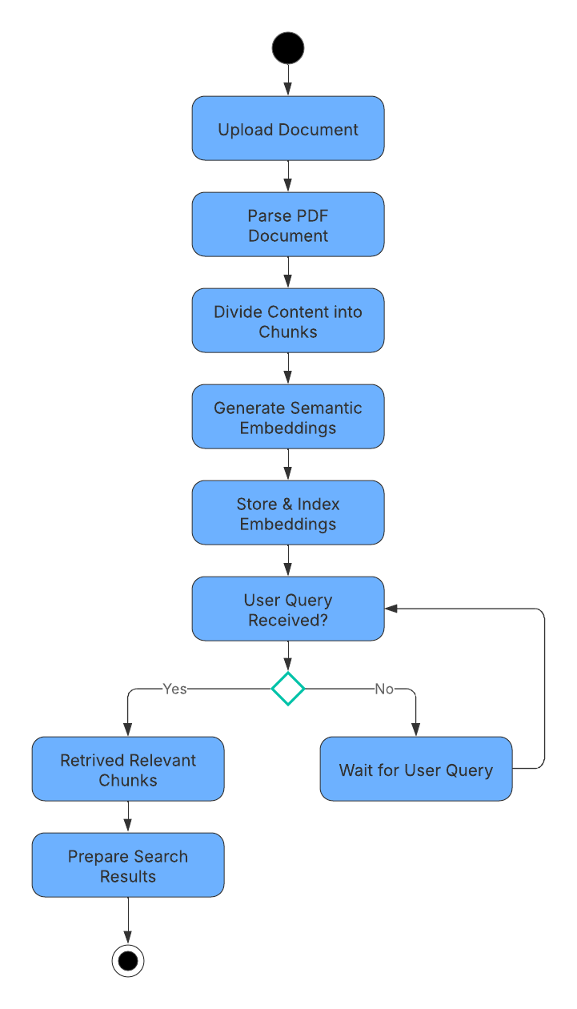

Figure 26: RE-ActivityDiagram

### Language & Model Handling Module

#### SRS Document

Functional Requirement

Table 13: LM--FunctionalRequirement

|  |  |
| --- | --- |
| Requirement Code | Requirement Description |
| LM-F-1.0 | The system must automatically detect the language of uploaded document text. |
| LM-F-1.1 | |  | | --- | |  |  |  | | --- | | The system must support detection of English and Nepali languages. | |
| LM-F-1.2 | The system must classify documents as either English or Nepali before further processing. |
| LM-F-1.3 | The system must route English documents to the LEGAL-BERT model for processing. |
| LM-F-1.4 | The system must route Nepali documents to NyayaLM fine-tuned on Nepali legal datasets. |
| LM-F-1.5 | The system must ensure that only the appropriate language-specific model processes each document. |
| LM-F-1.6 | |  | | --- | |  |  |  |  |  | | --- | --- | --- | | |  | | --- | |  |  |  | | --- | | The system must allow seamless integration with downstream retrieval and response generation modules. | | |

Non-Functional Requirement

Table 14: LM--Non-FunctionalRequirement

|  |  |
| --- | --- |
| Requirement Code | Requirement Description |
| LM-NF-1.0 | |  | | --- | |  |  |  |  |  | | --- | --- | --- | | |  | | --- | |  |  |  | | --- | | Language detection must complete within acceptable time limits without noticeable delay to the user. | | |
| LM-NF-1.1 | |  | | --- | |  |  |  | | --- | | Model routing must be accurate and reliable to prevent incorrect language-model assignment. | |
| LM-NF-1.2 | |  | | --- | |  |  |  | | --- | | The subsystem must support concurrent processing of multiple documents. | |
| LM-NF-1.3 | The subsystem must operate securely and must not expose document content to unauthorized components. |

Usability Requirement

Table 15: LM--UsabilityRequirement

|  |  |
| --- | --- |
| Requirement Code | Requirement Description |
| LM-UR-1.0 | The language detection and model routing process must be fully automatic and require no user interaction. |
| LM-UR-1.1 | |  | | --- | |  |  |  |  |  | | --- | --- | --- | | |  | | --- | |  |  |  | | --- | | The system must provide clear logs or status indicators for successful language detection and routing. | | |
| LM-UR-1.2 | |  | | --- | |  |  |  | | --- | | Errors in language detection or model selection must be clearly reported for administrative review. | |

#### Use Case Diagram

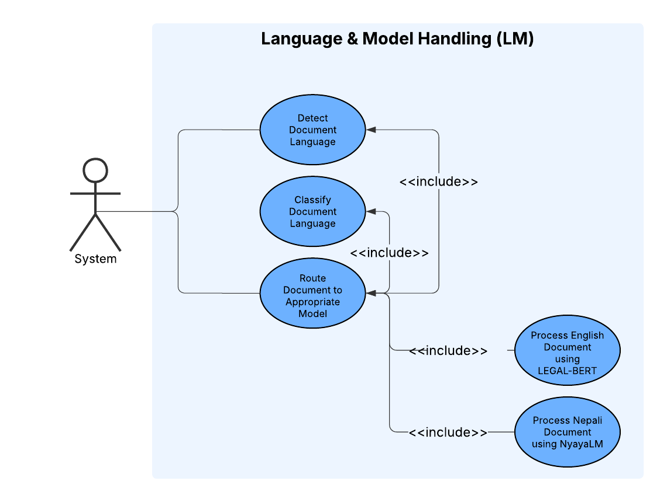

Figure 27: LM-UseCaseDiagram

#### Activity Diagram

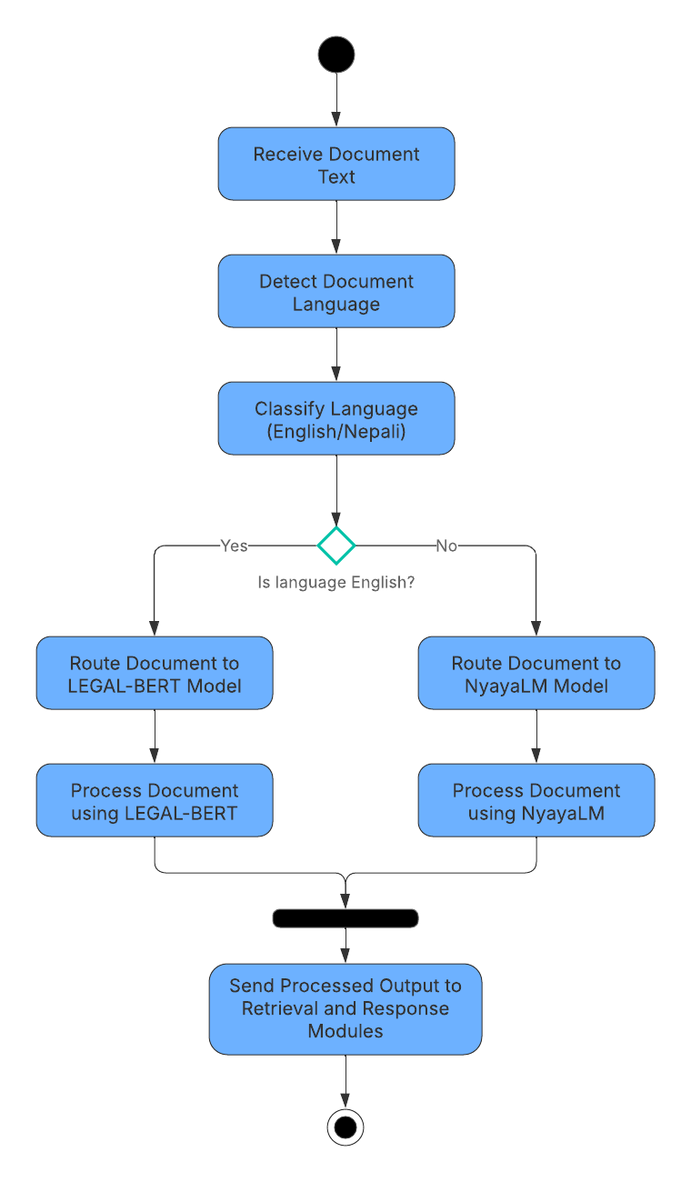

Figure 28: LM-ActivityDiagram

### Legal NLP Processing Module

#### SRS Document

Functional Requirement

Table 16: NLP--FunctionalRequirement

|  |  |
| --- | --- |
| Requirement Code | Requirement Description |
| NLP-F-1.0 | The system must support legal question answering (Q&A) based on user queries. |
| NLP -F-1.1 | |  | | --- | |  |  |  | | --- | | The Q&A system must generate citation-first answers referencing source documents. | |
| NLP -F-1.2 | The system must extract and identify legal entities including case names, statutes, sections, and organizations. |
| NLP -F-1.3 | The system must generate summaries at the document level. |
| NLP -F-1.4 | The system must generate summaries at the content-chunk level. |
| NLP -F-1.5 | The system must estimate semantic similarity between legal documents. |
| NLP -F-1.6 | |  | | --- | |  |  |  | | --- | | The system must support cross-referencing of related legal documents for comparative analysis. | |
| NLP -F-1.7 | |  | | --- | |  |  |  | | --- | | The system must integrate retrieved document content from upstream retrieval modules. | |

Non-Functional Requirement

Table 17: NLP--Non-FunctionalRequirement

|  |  |
| --- | --- |
| Requirement Code | Requirement Description |
| NLP -NF-1.0 | |  | | --- | |  |  |  |  |  | | --- | --- | --- | | |  | | --- | |  |  |  | | --- | | The system must generate responses within acceptable time limits for interactive use. | | |
| NLP -NF-1.1 | |  | | --- | |  |  |  |  |  | | --- | --- | --- | | |  | | --- | |  |  |  | | --- | | Citation accuracy must be maintained to ensure traceability to original legal sources. | | |
| NLP -NF-1.2 | |  | | --- | |  |  |  | | --- | | The subsystem must support concurrent processing of multiple documents. | |
| NLP -NF-1.3 | |  | | --- | |  |  |  | | --- | | The system must ensure data confidentiality and must not expose document content to unauthorized components. | |

Usability Requirement

Table 18: NLP--UsabilityRequirement

|  |  |
| --- | --- |
| Requirement Code | Requirement Description |
| NLP -UR-1.0 | Generated answers must be presented in clear, structured, and readable format. |
| NLP -UR-1.1 | |  | | --- | |  |  |  |  |  | | --- | --- | --- | | |  | | --- | |  |  |  | | --- | | Citations must be clearly visible and linked to their corresponding source documents. | | |
| NLP -UR-1.2 | Summaries must be concise and understandable for non-technical users. |
| NLP -UR-1.3 | The system must present similarity and cross-reference results in an interpretable manner. |

#### Use Case Diagram

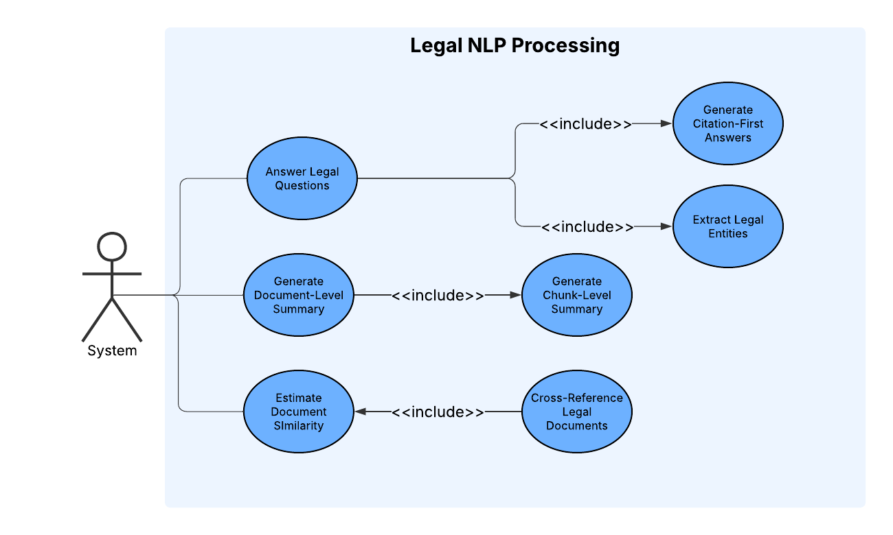

Figure 29: NLP-UseCaseDiagram

#### Activity Diagram

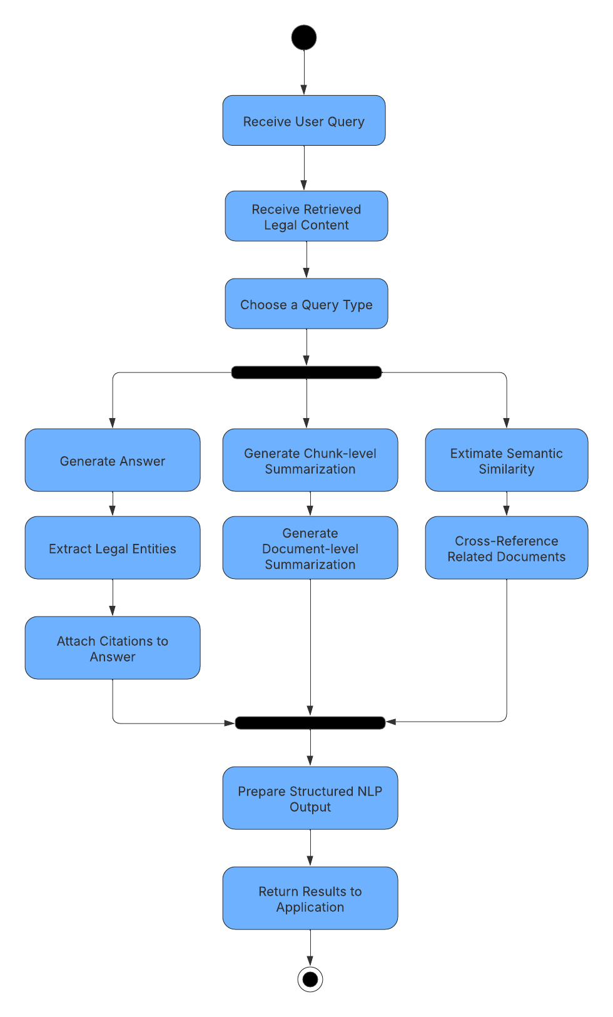

Figure 30: NLP-ActivityDiagram

### Frontend & User Interface Module

#### SRS Document

Functional Requirement

Table 19: FUI--FunctionalRequirement

|  |  |
| --- | --- |
| Requirement Code | Requirement Description |
| FUI-F-1.0 | The system must provide a web-accessible user interface. |
| FUI -F-1.1 | |  | | --- | |  |  |  | | --- | | The web interface must allow users to upload PDF documents. | |
| FUI -F-1.2 | The system must provide a chat interface for interacting with the legal assistant. |
| FUI -F-1.3 | |  | | --- | |  |  |  | | --- | | The chat interface must allow users to submit legal questions in real time. | |
| FUI -F-1.4 | The system must display citation-first responses within the chat interface. |
| FUI -F-1.5 | The interface must display uploaded document lists and their upload status. |
| FUI -F-1.6 | |  | | --- | |  |  |  |  |  | | --- | --- | --- | | |  | | --- | |  |  |  | | --- | | The system must allow users to view responses generated by backend NLP modules. | | |
| FUI -F-1.7 | |  | | --- | |  |  |  | | --- | | The system must support interaction with multiple backend subsystems seamlessly. | |

Non-Functional Requirement

Table 20: FUI--Non-FunctionalRequirement

|  |  |
| --- | --- |
| Requirement Code | Requirement Description |
| FUI -NF-1.0 | |  | | --- | |  |  |  |  |  | | --- | --- | --- | | |  | | --- | |  |  |  | | --- | | The web interface must be accessible via standard web browsers. | | |
| FUI -NF-1.1 | |  | | --- | |  |  |  |  |  | | --- | --- | --- | | |  | | --- | |  |  |  | | --- | | All data exchanged between the client and server must be transmitted over HTTPS/TLS. | | |
| FUI -NF-1.2 | |  | | --- | |  |  |  | | --- | | The user interface must respond to user actions within acceptable time limits. | |
| FUI -NF-1.3 | |  | | --- | |  |  |  |  |  | | --- | --- | --- | | |  | | --- | |  |  |  | | --- | | The interface must handle multiple simultaneous users without performance degradation. | | |
| FUI -NF-1.4 | The frontend must prevent unauthorized access to protected system features. |

Usability Requirement

Table 21: FUI--UsabilityRequirement

|  |  |
| --- | --- |
| Requirement Code | Requirement Description |
| FUI -UR-1.0 | The user interface must be intuitive and easy to navigate. |
| FUI -UR-1.1 | |  | | --- | |  |  |  |  |  |  |  | | --- | --- | --- | --- | --- | | |  | | --- | |  |  |  |  |  | | --- | --- | --- | | |  | | --- | |  |  |  | | --- | | The document upload interface must support drag-and-drop functionality. | | | |
| FUI -UR-1.2 | The chat interface must display responses in a clear and readable format. |
| FUI -UR-1.3 | |  | | --- | |  |  |  | | --- | | Citations in chat responses must be clearly visible and easy to understand. | |
| FUI -UR-1.4 | The interface must provide feedback messages for successful or failed actions. |
| FUI -UR-1.5 | The interface must maintain consistent layout and styling across all pages. |

#### Use Case Diagram

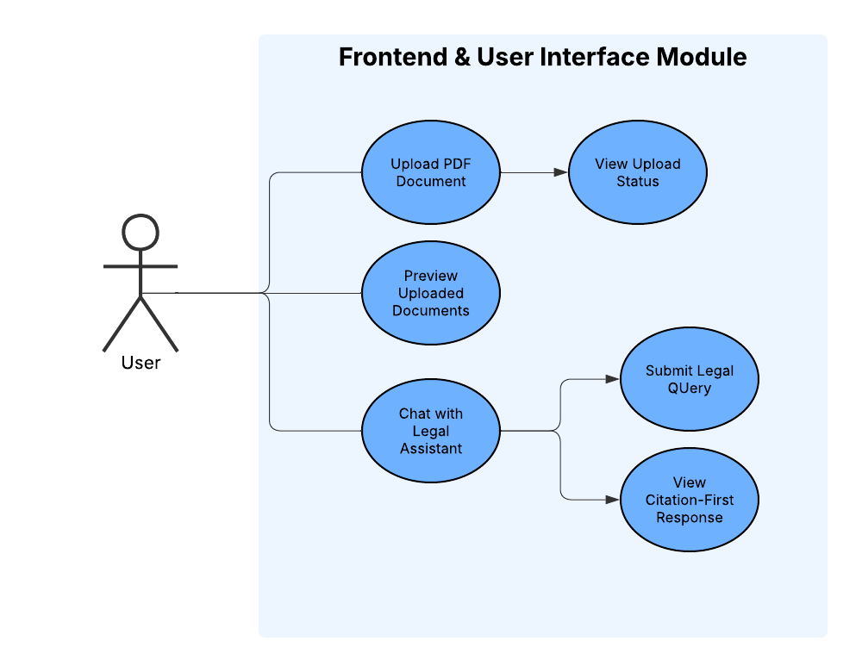

Figure 31: FUI-UseCaseDiagram

#### Activity Diagram

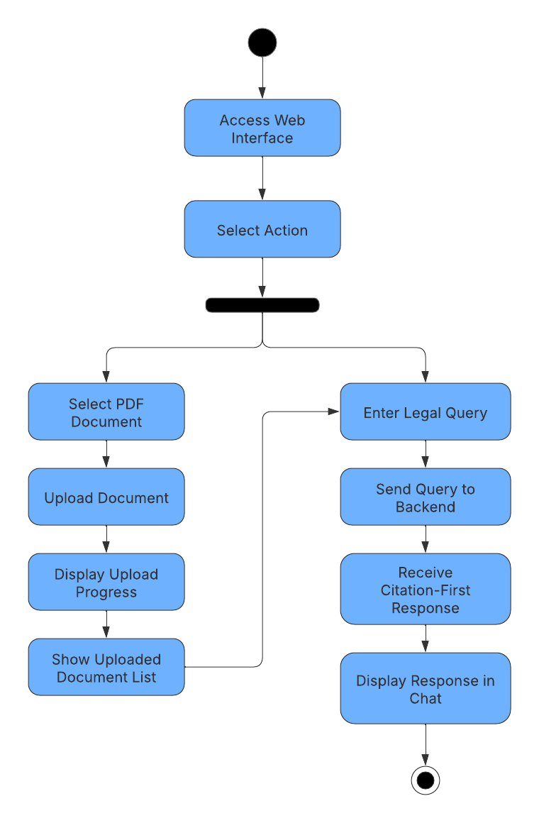

Figure 32: FUI-ActivityDiagram

### Security & Deployment Module

#### SRS Document

Functional Requirement

Table 22: SD--FunctionalRequirement

|  |  |
| --- | --- |
| Requirement Code | Requirement Description |
| SD-F-1.0 | The system must ensure end-to-end encryption for all uploaded legal documents. |
| SD -F-1.1 | The system must encrypt data during transmission using secure communication protocols. |
| SD -F-1.2 | The system must encrypt stored documents to prevent unauthorized access. |
| SD -F-1.3 | |  | | --- | |  |  |  | | --- | | The system must implement access control mechanisms based on user authentication and authorization. | |
| SD -F-1.4 | |  | | --- | |  |  |  | | --- | | The system must prevent unauthorized users from accessing protected documents and system features. | |
| SD -F-1.5 | |  | | --- | |  |  |  | | --- | | The system must deploy the application as a cloud-based SaaS solution. | |
| SD -F-1.6 | |  | | --- | |  |  |  |  |  | | --- | --- | --- | | |  | | --- | |  |  |  | | --- | | The system must support secure access from multiple devices and locations. | | |
| SD -F-1.7 | |  | | --- | |  |  |  | | --- | | The system must integrate security controls across all subsystems. | |

Non-Functional Requirement

Table 23: SD--Non-FunctionalRequirement

|  |  |
| --- | --- |
| Requirement Code | Requirement Description |
| SD -NF-1.0 | |  | | --- | |  |  |  | | --- | | All data transmission must use industry-standard encryption protocols (HTTPS/TLS). | |
| SD -NF-1.1 | |  | | --- | |  |  |  |  |  | | --- | --- | --- | | |  | | --- | |  |  |  | | --- | | Encryption mechanisms must not significantly degrade system performance. | | |
| SD -NF-1.2 | |  | | --- | |  |  |  | | --- | | The system must maintain high availability in a cloud environment. | |
| SD -NF-1.3 | |  | | --- | |  |  |  |  |  | | --- | --- | --- | | |  | | --- | |  |  |  | | --- | | The system must be scalable to handle increasing numbers of users and documents. | | |
| SD -NF-1.4 | The system must comply with basic data security and privacy best practices. |

Usability Requirement

Table 24: SD--UsabilityRequirement

|  |  |
| --- | --- |
| Requirement Code | Requirement Description |
| SD -UR-1.0 | Security features must operate transparently without requiring user intervention. |
| SD -UR-1.1 | |  | | --- | |  |  |  |  |  |  | | --- | --- | --- | --- | | |  | | --- | |  |  |  |  | | --- | --- | | |  | | --- | |  |   Access-denied messages must be clearly displayed when unauthorized actions are attempted. | | |
| SD -UR-1.2 | |  | | --- | |  |  |  | | --- | | Users must be able to access the system securely from different devices and browsers. | |

#### Use Case Diagram

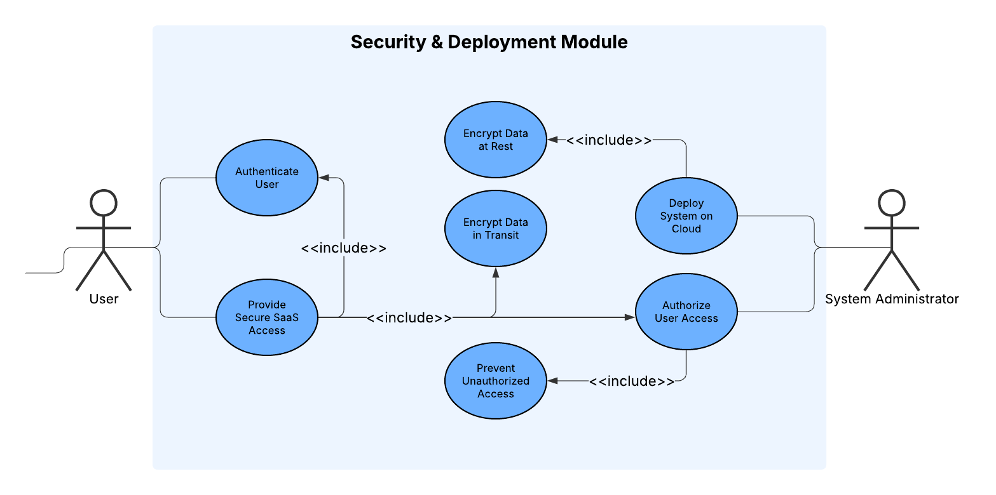

Figure 33: SD-UseCaseDiagram

#### Activity Diagram

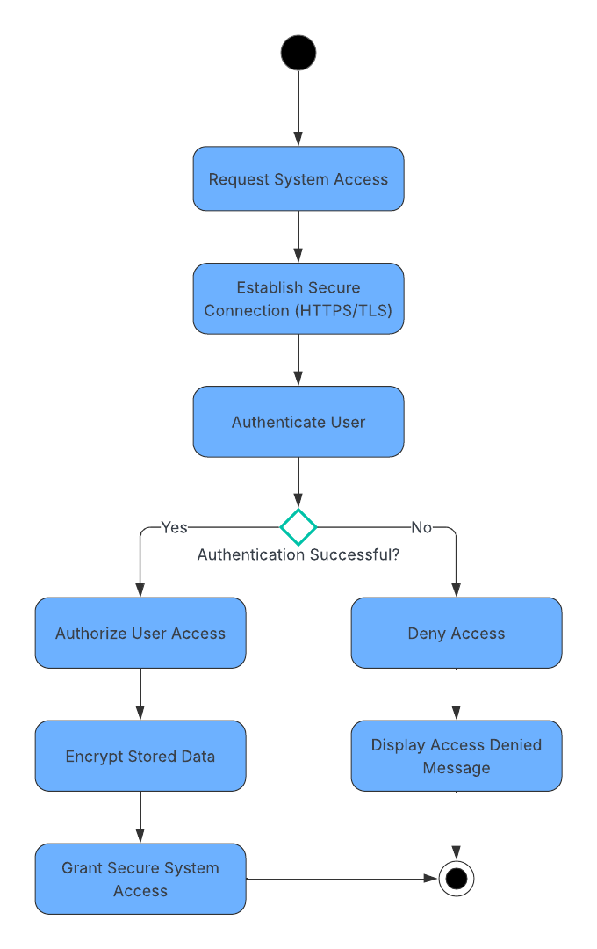

Figure 34: SD-ActivityDiagram

# Test Plan

## User Management Module

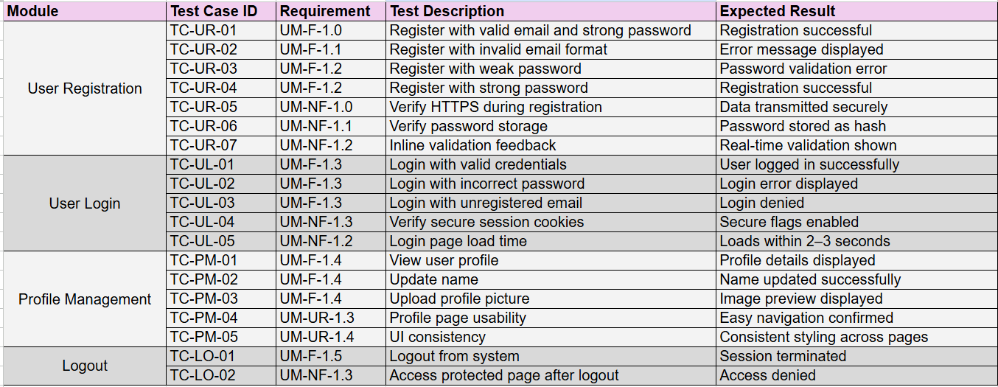

Figure 35: UM-TestPlan

## Document Management Module

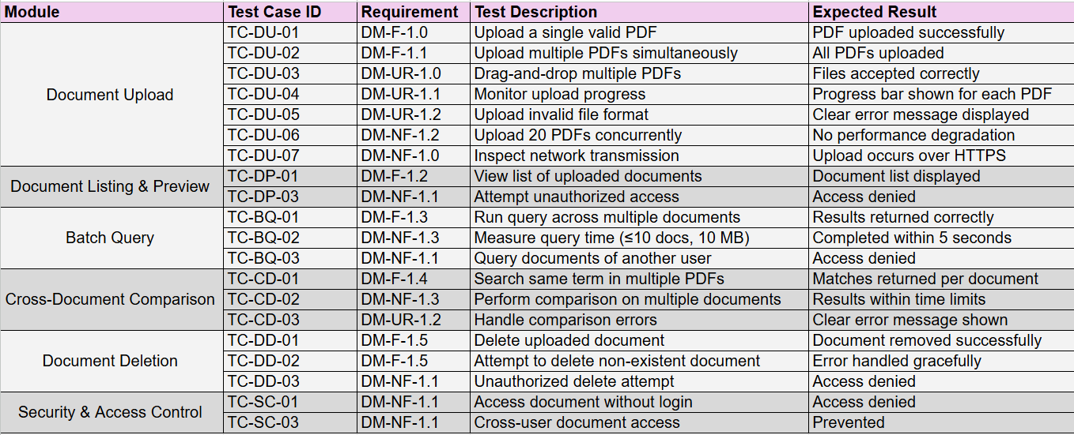

Figure 36: DM-TestPlan

## Personalization Module

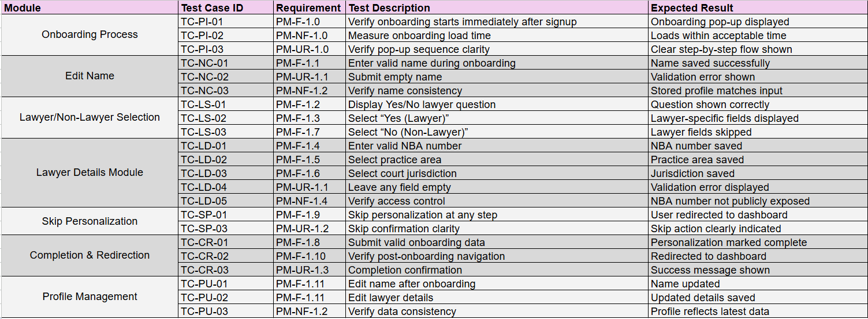

Figure 37: PM-TestPlan

## Retrieval & Embedding Module

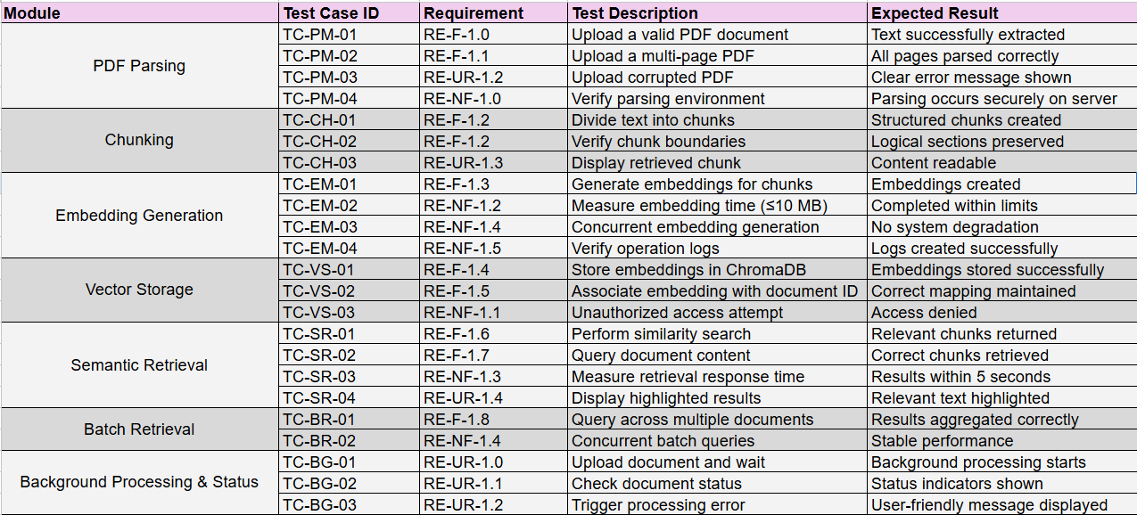

Figure 38: RE-TestPlan

## Language & Model Handling Module

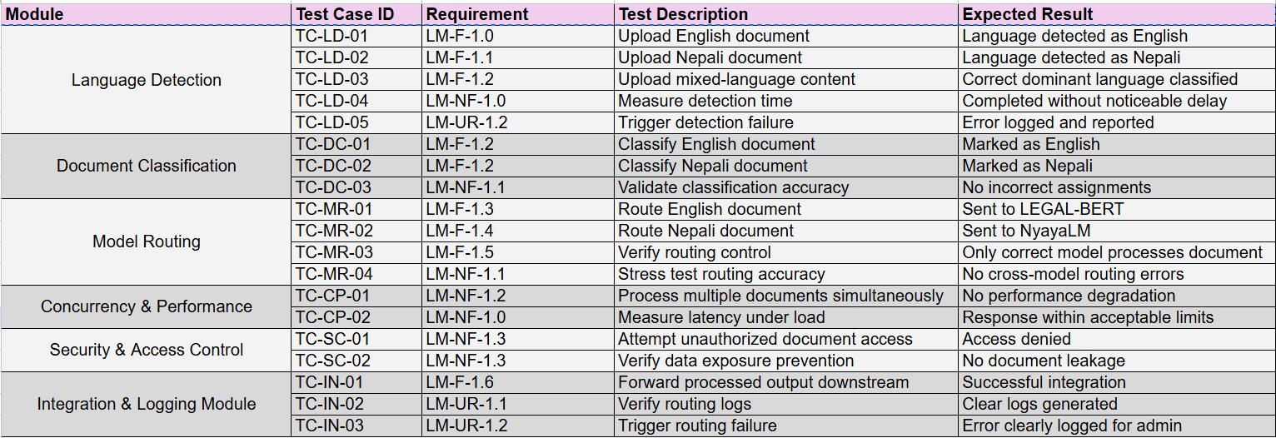

Figure 39: LM-TestPlan

## Legal NLP Processing Module

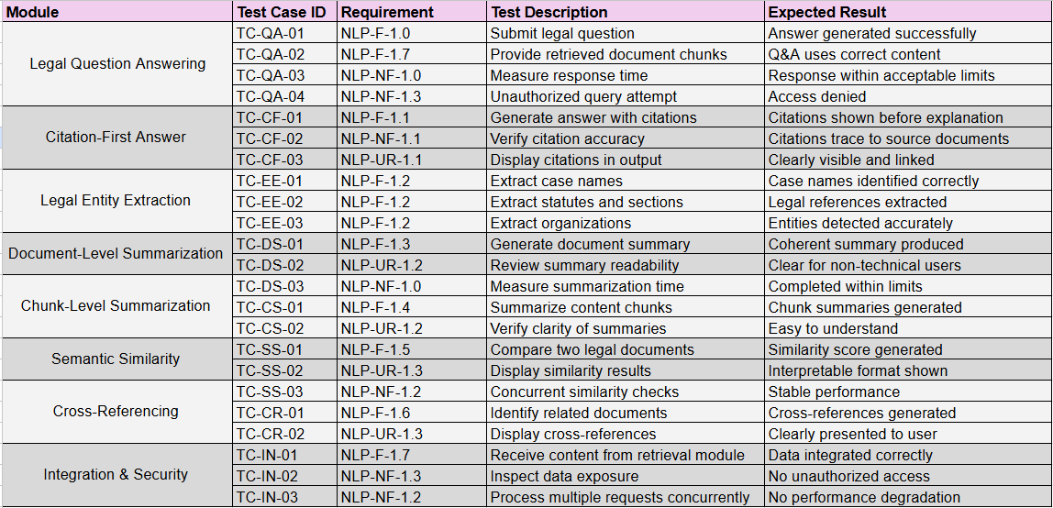

Figure 40: NLP-TestPlan

## Frontend & User Interface Module

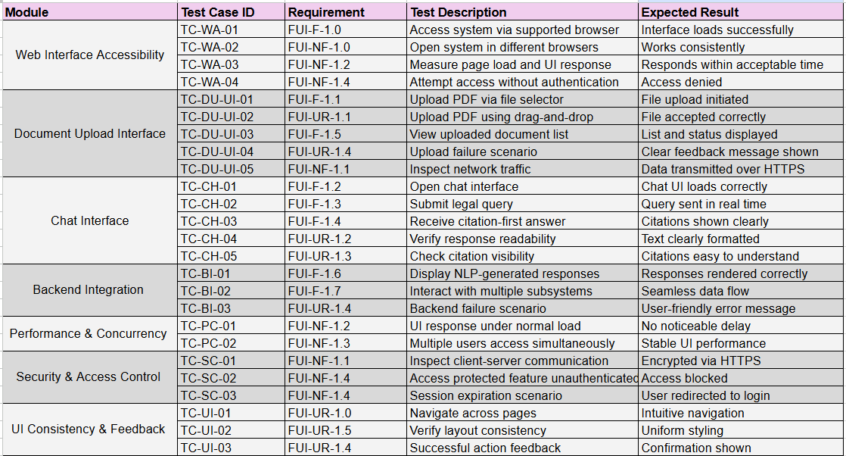

Figure 41: TestPlan

## Security & Deployment Module

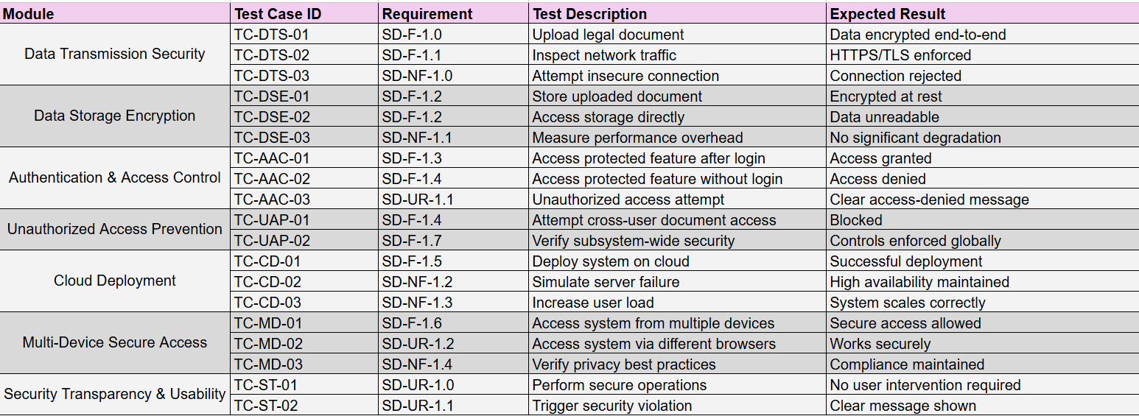

Figure 42: SD-TestPlan